Title Page: SHIELD STRATEGIC PLAN

National Strategy for the Laboratory Interoperability and Pandemic Preparedness

EXECUTIVE SUMMARY

[Executive Summary goes here]

TABLE OF CONTENTS
EXECUTIVE SUMMARY i
TABLE OF CONTENTS ii
LIST OF TABLES iii
LIST OF FIGURES iv
ACKNOWLEDGEMENTS v
INTRODUCTION 1
The SHIELD Strategic Planning Process 1
SHIELD and National Pandemic Preparedness 3
Scope of Effort 5
BACKGROUND 6
Systemic Harmonization and Interoperability Enhancement for Laboratory Data (SHIELD) 6
Current State: Barriers to Laboratory Interoperability 8
Future State: US Laboratory Interoperability 10
Clinical Interoperability 11
Expanded LIVD File 11
LAW 11
Supporting HIE, Public Health Surveillance and other aggregations. 11
Highly Reliable Data/Patient Safety 11
Global Harmonization 12
STRATEGIES 13
Strategy 1: Expanded LIVD File [how from LIVD Comm] 13
Strategy 2: Laboratory System Transformation [how from Implementation Comm] 13
Strategy 3: Strategic Alignment 13
Strategy 4: Tools and Knowledge Management 16
Strategy 5: Communication and Training 16
Strategy 6: Working with Industry 16
Strategy 7: Monitoring and Evaluation 17
ACTIVITIES ROADMAP 21
FUNDING MODEL AND ALLOCATION 22
MOVING FORWARD 22
APPENDIXES 23

LIST OF TABLES

LIST OF FIGURES

ACKNOWLEDGEMENTS

INTRODUCTION
[Content to go here]

The SHIELD Strategic Planning Process
The most obvious reason to engage in organizational strategic planning is that it provides direction and focus by way of a written document. Having a clearly articulated mission and vision enables entities to develop a strategic plan that is a literal roadmap for success. The purpose for the development of a strategic plan for SHIELD is to connect its mission and vision by addressing these three questions:
- What is the purpose (Mission)?
- What do we want to achieve (Vision)?
- How are we going to get there? (Plan)?
The SHIELD partnership was formed to develop a strategic plan that will outline a possible roadmap, within a 3-5 year timeline, for all stakeholders and partners to move the US laboratory system to interoperability through adoption of harmonized coding. The strategic plan will set the guiding principles of SHIELD’s approach by:
- Articulating a clear mission and vision in a written document: SHIELD’s mission provides the organization with a clear and effective guide for making decisions, while its vision ensures that all the decisions made are properly aligned with what the organization hopes to achieve.
- Driving organizational alignment: a strategic plan isn’t just a document to keep everyone on track. Having everyone participate in the strategic planning process fosters collegiality and creates an opportunity for discussion on the direction of the organization, which is why strategic planning often results in cultural transformation. In addition, the process promotes the open and creative exchange of ideas, including resolving disputes and working out effective solutions.
- Enhancing Execution: confusion and day-to-day organizational fires are often reasons why strategic planning yields little results, but these risks can be mitigated by having a plan that is written down, with clear assignments, dues dates, and deliverables, so that all stakeholders know what must be executed by when.
- Creating a roadmap and justify funding for leading US labs to interoperability: a roadmap allows for decision makers and leaders to be strategic when they evaluate initiatives. The overall strategic plan for SHIELD will be used to evaluate, assess and execute on key success factors and outcomes to achieve SHIELD’s goals and make it clear to key funders why this particular mission is important. The roadmap will justify SHIELD’s long term vision on three fronts: 1) public value to be created 2) sources of legitimacy and support 3) operational capacity to deliver the value
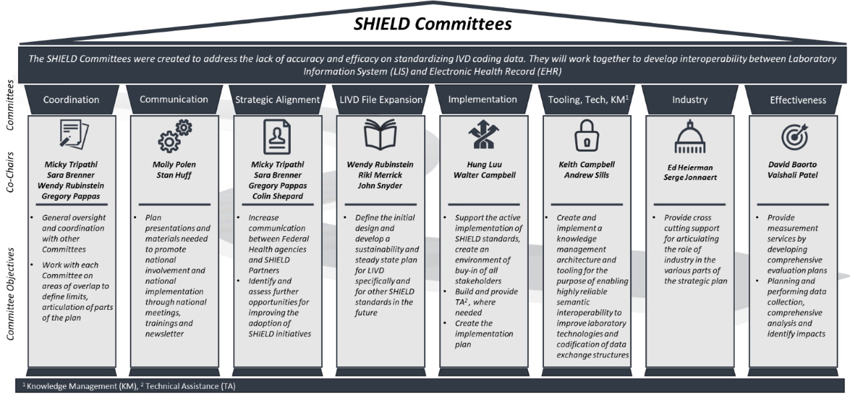
The Strategic Plan will focus on updating laboratory systems and IVD data at demonstration sites to adhere to best practices from the FDA SHIELD IVD Semantic Interoperability Working Group. The Strategic Plan is the byproduct of collaboration from 8 committees; comprising of co-chairs, and members. The formation of committees started during the week of April 29th into the first few weeks of May. By May 14th, all committees and committee co-chairs were identified. Simultaneously, during that second week of May Committee members were recruited, on a volunteer basis through a survey. According to the survey responses, approximately 45 SHIELD members were ready to participate in these 8 different committees. Member profiles represented various health care and, life science industries and thought leaders in laboratory interoperability to ensure a strong representation from a variety of stakeholders and breadth of knowledge/ideas. The 8 committees were made up of the following, also depicted in Figure 1:
- Coordination Committee
- Communication Committee
- Strategic Alignment Committee
- LIVD File Expansion Committee
- Implementation Committee
- Tooling, Technology and Knowledge Management (KM) Committee
- Industry Committee
- Effectiveness Committee (Program Evaluation)
To formally kick-off this 12-week strategic planning process, committee co-chairs held initial meetings to align on standard operating procedures and approach for completing this strategic plan. These meetings were then followed by committee wide membership meetings to address the most pressing strategies that aligned with the vision and mission of SHIELD. Under the leadership of committee co-chairs, and voluntary dedicated time of committee members, each committee was asked to identify at least 3 strategies, categorize action items for each and provide a roadmap for implementation within the 3-5 year timeline that tied to a specific budget or funding amount. These committee-level strategic plans were aggregated to create the SHIELD strategic plan.

SHIELD and National Pandemic Preparedness
The COVID-19 pandemic required a rapid SHIELD focus on SAR-CoV-2 testing. And, EUA (Emergency use authorized) assays for COVID-19 testing were being authorized without the LOINC codes needed for laboratory interoperability and reporting. This ‘tragic data gap’ exposed by the COVID-19 pandemic has undermined the national response to the emergency. The challenges of establishing an adequate COVID-19 diagnostic test surveillance system in 2020 has made clear the importance of lab test result data interoperability as a condition of pandemic preparedness.
The Coronavirus Aid, Relief, and Economic Security (CARES) Act, required “every laboratory that performs or analyzes a test that is intended to detect SARS-CoV-2 or to diagnose a possible case of COVID-19” to report the results from each test to HHS. On June 4, 2020, the HHS announced new laboratory data reporting guidance for standardized COVID-19 testing data elements of LOINC test order, LOINC test result, SNOMED-CT test description, SNOMED-CT specimen source, and Device Identifier. These requirements posed many challenges for laboratories, one of which being unable to report COVID Data. This is amid overarching supply shortages and other difficult labs faced during the pandemic. As a result, SHIELD developed the pandemic-specific LIVD specification for SARS CoV-2 Tests. Currently, SHIELD creates and maintains the LIVD specification promulgated through CDC for purposes of standardizing reporting SARS-CoV-2 test results. And, SHIELD provides the authoritative source of coding for COVID-19 testing and a wide variety of other assays.
SHIELD Recognition:
SHIELD’s effort during the COVID-19 pandemic led to HHS recognition of SHIELD and allowed for $550M to be directed to APHL as a response to the pandemic for data modernization.
Still, laboratory interoperability remains a major obstacle to data collection and collaboration capabilities of health data systems in supporting the detection of and response to high-consequence public health threats. Laboratory data are difficult to interpret and aggregate because of differences in the way laboratories and healthcare systems code tests. Accurate, timely information on national patterns of infections, supply shortages and quality of tests require that laboratories use standardized coding across the country.

Scope of Effort
[Explicitly state no LDTs]

BACKGROUND

Systemic Harmonization and Interoperability Enhancement for Laboratory Data (SHIELD)
What is SHIELD? The Food and Drug Administration’s (FDA) Systemic Harmonization and Interoperability Enhancement for Laboratory Data (SHIELD) is a public-private partnership that was assembled with a singular focus on improving the interoperability and utility of in-vitro diagnostic (IVD) test data through the harmonized implementation of semantic data standards that have been appropriately qualified by a sole authoritative source. Codes for laboratory data should be interoperable; “Describe the same test same way, every time”.
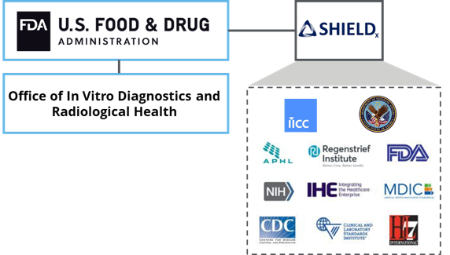
Laboratory in vitro diagnostics (IVD) testing makes up a significant portion of Electronic Health Record (EHR) data and these test results are used in approximately 70% of decisions made that influences patient care. The misrepresented or loss of IVD test data due to interoperability failures have had critical consequences. IVDs are used to gain insight into patient’s physiologic status (e.g., glucose levels, disease presence/absence), which helps guide clinical decisions and subsequent therapeutic actions. Semantic interoperability is essential to ensuring that the IVD test results are accurately and consistently described within EHRs.
By improving the semantic interoperability of laboratory data within and between institutions, diagnostic information can be used to better support clinical decisions and enable Real World Evidence (RWE) relevance and reliability. SHIELD supports the provision of vetted and harmonized codes from manufacturers/industry to laboratories; this enables consistent representation in Laboratory Information Systems (LIS) and in the downstream EHR systems, achieving cross-institutional semantic interoperability.
Benefits of SHIELD:
- Eases administrative and clinical burden for all stakeholder groups through a unified approach
- Advances greater standards-based information exchange across laboratories and healthcare institutions
- Lays the foundation for improved semantic interoperability by implementing infrastructure that directly harmonizes the process of how laboratory data standards are practically applied to IVD test data

SHIELD
Vision: Shared vision of laboratory interoperability across the US to advance innovation and reduce burdens to the healthcare knowledge workers, increase patient safety and streamline knowledge management.
Mission: Aim to provide highly reliable laboratory knowledge to public, private, and professional organizations.
SHIELD’s goal is cross institutional laboratory data Interoperability by developing a publicly available infrastructure to improve the quality, interoperability and portability of laboratory data within and between institutions for enabling public health reporting, healthcare research and innovation, Clinical Decision Support (CDS), regulatory decisions, outbreak monitoring, signal detection and RWE.
SHIELD will accomplish this by:
- Conducting an exploratory analysis of healthcare terminology data to identify differences that might exist within laboratory code data in EHRs and LIS’s
- Assessing electronic healthcare system interoperability pre- and post-implementation, including comparative associations with ICD codes and CPT codes, used for diagnosis and reimbursement claims
- Compiling and preparing findings for dissemination/publication by SHIELD and IHIs
- Increasing semantic interoperability at each IHI and be an example to share with other healthcare systems to improve regulatory decisions, realize real-time epidemiology, enhance clinical decision support and enable research related to key diseases

Current State: Barriers to Laboratory Interoperability
According to Office of National Coordinator for Health Information, there are currently 6 barriers to health care interoperability
- Landscape Analysis [CAP?]

- Technical barriers - "These limit interoperability through — for example — a lack of standards development, data quality, and patient and healthcare provider data matching."
For example, in order for systems to be interoperable, there must be a shared understanding of what certain concepts mean. In the laboratory domain, there are many examples related to how tests are defined that emphasize this point. For instance, if a printed report says that the glucose level is 100 mg/dL, and does not give any more information, most clinicians would automatically assume that this was a serum/plasma sample, as opposed to a urine sample or a sample drawn as part of a glucose tolerance test. However, electronic systems don’t have this ability to draw inferences; so, in order to transmit test results successfully, we need to have a system for ensuring that both the sending and receiving system know how to interpret and file a given result. Another example is a therapeutic drug level, such as gentamicin. If the laboratory system has only a generic definition of a gentamicin, but the receiving system has separate results choices for “gentamicin, peak,” “gentamicin, trough” and “gentamicin, random,” then it is hard to know how to link the tests between the two systems.
- Financial barriers - "These relate to the costs of developing, implementing and optimizing health IT to meet frequently changing requirements of healthcare programs," including lack of incentives for sharing information and need for business models for secondary uses of data.
- Trust barriers - "Legal and business incentives to keep data from moving present challenges. Health information networks and their participants often treat individuals' electronic health information as an asset that can be restricted to obtain or maintain competitive advantage."
- Administrative requirements - "Federal documentation and administrative requirements (including billing requirements) contribute to health IT burden due to outdated guidelines for evaluation and management codes that unnecessarily link payment to documentation."
- Reporting requirements - "Federal reporting requirements in some cases add burden to healthcare providers by requiring them to report on quality measures that are not relevant or meaningful."
- IT usability - "Health IT system design and usability barriers identified by stakeholders include ... variations in the design [of user-interfaces] that make day-to-day use complicated when a healthcare provider uses multiple systems and the lack of developer engagement with end users of health IT regarding design needs."
Insert USE CASE scenarios

Future State: US Laboratory Interoperability
It is understandable that health systems, payers, providers and hospitals are all on-board with seeking innovative yet, manageable approaches to interoperability in healthcare. Some advances in analytics, such as intelligent organization of claims, accurate diagnosis, computer assisted coding and patient insight using artificial intelligence, NLP technology and medical Machine Learning will be at the forefront of methods that will drive these endeavors forward. Real-time data exchange of relevant healthcare information during each step of the information chain will not only improve quality of care but the efficiency in which it is delivered will be the center of value-based healthcare. Therefore, it is important to work with thought leaders in the world of interoperability in an effort to adopt SHIELD’s approach to improve their internal interoperability.
Additionally, the COVID-19 pandemic has woken the healthcare system to the reality that the US does not have a uniform health system and that healthcare in the United States is provided by many distinct organizations. As a result, the healthcare delivery system is not as reliable as other industries. Thus, increasing the need for strong business and clinical requirements to achieve a High Reliability Organization (HRO) status and to generate reliable performance results in healthcare. An HRO model is an environment of “collective mindfulness” where all physicians, caregivers, employees, management, and key stakeholders look for, and report, small problems or unsafe conditions before they pose a substantial risk to their patients and when they are easy and affordable to fix. Especially, in recent years, healthcare consumers, providers, payers, and other key stakeholders have demanded better patient care, heightened patient safety and improved business outcomes. And, implementing an effective HRO model helps physician practices’ leaders and practitioners design their organizations around anticipating and preventing problems. Therefore, achieving interoperability across the U.S laboratories will put SHIELD as the driving force and center of this shared vision and common goal of achieving consistent and reliable patient care outcomes and sustainable business performance results for many healthcare entities/organizations.
Scenarios are a good place to strategic plan to end. There are difference potential scenarios that will bring in various parts of a very large system.
- Creation of the LIVD coding on routine base
- Repository and authority
- Use scenarios that sustain the ecosystem?
- CAP xxx
- IVQ Data Hub

Clinical Interoperability

Expanded LIVD File

LAW

Supporting HIE, Public Health Surveillance and other aggregations.

Notes

SHIELD in the Steady State [what are the functions of SHILED in the future state]
- Convene stakeholders
- Ensure ongoing Quality of data
- Accommodate new data needs
- Accommodate new technology needs

Highly Reliable Data/Patient Safety

Global Harmonization
[What is this section? Requested by GP]

STRATEGIES

Strategy 1: Expanded LIVD File [how from LIVD Comm]

Strategy 2: Laboratory System Transformation [how from Implementation Comm]

Strategy 3: Strategic Alignment
- [How to] Identification of alignment partners
  - Prepare package for Micky to speak with Agency Heads
    - Schedule meetings for Micky
    - Propose that Agencies spin up teams within the Agency
      - What are the agency barriers, review and analysis of agency policies related to SHIELD
      - Plans to reform
      - Presentations at major forums and publications
  - Phase II Strategy Development (based on assessment and engagement by agencies)
    - Starts Year 2
  - Metrics: (1) committees Formed and (2) plans made
  - Tools: Planning tool for alignment
  - Phase 3: Development of Mature SHILED governance and authority/Future State

Notes:
The Strategic Plan will also propose clearly defined lines of authority and roles and responsibilities across the SHIELD program team. SHIELD leadership works with CDRH counterparts to translate the program’s high-level strategy and priorities into actionable plans and execution at the working-level. A governance body, perhaps driven by the implementation committee can provide technical assistance and disseminate best practices and other information to support and accelerate efforts. This is essential for rapid and successful implementation of HHS data reporting requirements. Additionally, support services, targeted outreach, and a small grants program are proposed to support implementation of coding standards. This section can also contain details around the following:
- Analyze and identify recommendations to improve program governance
- Update the program governance plan
- Create and maintain a decision authority matrix by building upon the current decision-making processes
- Track and monitor decisions in the SHIELD decision log and identify impacts to communicate decisions to committee stakeholders.
Strategic alignment between the many government and non-governmental stakeholders of SHIELD and is critical to the transformation needed to bring about laboratory data interoperability. The steps proposed in this Strategic Plan must happen at many points in the clinical laboratory starting with manufacturing, ordering of tests, laboratory processing, and the many down stream uses of the data from clinical reporting, billing, surveillance, and research.

Table x below lists SHIELD stakeholders and the alignment that this strategic plan recommends. These range from policy changes, to investment and programmatic action. Both government agencies (federal and state) and non-government stakeholders (manufacturers, coding organizations, laboratories, and professional society) need to act to move the national laboratory system towards interoperable, efficiency and improved patient safety.
Strategic alignment of stakeholders is proposed in three phases. The first phase will work to engage the leadership of the many stakeholders and develop more specific analysis of barriers to reform. The second phase will be to develop and implement a plan to help the partner stakeholders to update and develop their procedures and process to support interoperability. The third phase is to evaluate the efforts. This would take place over a three-year period.

The strategic alignment works with each stakeholder organization separately but also works to build a body that will provide governance and authority for interoperability in the future. This body will coordinate across the many government agencies and private sector organizations that play a role in interoperability.

Phase one – Engagement and assessment

- Develop a case and value proposition for each stakeholder
- Work with Deloitte consultants to inform agencies about potential role in SHIELD in advance of formal contact.
- Propose that ONC director meet with agency and organization heads meet with stakeholder leaders with a plan for collaboration
- Form collaborative committee (SHIELD and agency members) for each stakeholder
- Develop work plan for committee to continue work and implement as planned
- Publication
- First develop a draft plan for interagency governance of interoperability and hold first meeting of all agencies consider structure, functions and agents that would do this work. An possible convener could be ONC or ASPE/
Phase 2- Implementation
- Agency/organization specific committees begin work to move forward policy and process reform
- Second meeting of all stakeholder leadership to review reports of Phase one and develop terms of reference of a coordination body
- Publications
Phase 3 – Evaluation
- Evaluate implementation including potential pilots to be able to view data flow for each part of process
- Establishment of interoperability governance body for ongoing and authority to coordinate interoperability into future
- Publications

Table X. Strategic Alignment Map

Strategy 4: Tools and Knowledge Management
Strategies
- User Experience and Functionality - strategy for how stakeholders and end-users engage with the SHIELD tooling and available knowledge.
- Infrastructure and Integration - strategy for how the tooling and knowledge management environment will operate and integrate with external systems and standards.
- Knowledge Management and Analytics - strategy for how LIVD knowledge will be captured, versioned, and curated over time in a highly reliable and patient-safe way.
- Quality Assurance and IV&V - strategy for ensuring the quality, fit-for-purpose, and usefulness of available knowledge.

Tactics
- Solor Knowledge Architecture
- Solor Analysis Normal Form (ANF)
- Solor Tinkar
- Understandable, Reproducible, Useful (URU) Principle
- Use-case-driven, Architecture-centric, iterative and incremental
- HRO Knowledge Management

Strategy 5: Communication and Training
The communication committee will work to operationalize coordination, planning, management, and execution of multiple related initiatives across organizations utilizing appropriate level of support to realize shared vision of laboratory interoperability. The committee will contribute a Strategic Communications plan to build a transparent targeted, stakeholder- and data-informed communication campaign with clear channels of engagement and purposeful knowledge sharing. The communication plan will incorporate the following:
- A plan to build the system
- A plan to sustain the future state

Strategy 6: Working with Industry
Objective: The development and adoption promotion of semantic interoperability standards that are secure, well-structured, and easy to implement and maintain by IVD manufacturers.

Description of Intended Effort:
- Development and refinement of critical interoperability standards, including:
  - LIVD on FHIR
  - Expand LIVD and LAW functionality, including Value Set, UDI, and Specimen Mapping, as well interface improvements
  - Support integrations with emerging frameworks (e.g. SOLOR)
  - Support the development of the CLSI AUTO17 standard
  - Foundational interface improvements
- Drive adoption by IVD manufacturers through concerted effort of continued evangelization and education
Major 2020-2021 Goals/Milestones:
- Launch SHIELD LIVD evangelization/ educational program. Drive IVD manufacturer and national lab groups adoption program (2021)
- Complete the requirements for functionality expansion of LIVD and LAW
- Present at AACC and HIMSS (2022)
- Completion and launch of LIVD on FHIR standard (2022)
- Participation in HIMSS Interoperability Showcase to demonstrate LAW and LIVD support for interoperable systems (2022)

Strategy 7: Monitoring and Evaluation

Monitoring the implementation of coding standards and reporting will be used to guide the implementation work of the project and better understand the needs of those doing the implementation. The extent and quality of implementation of the coding standards and resultant reporting are critical sustainability of HHS Protec. The Effectiveness Committee will deploy evidence-based evaluation methodologies to support the rigorous measurement of performance effectiveness and the interpretation of data to achieve results-driven improvements for semantic interoperability of laboratory data while promoting operational efficiencies. Monitoring and evaluation of the national implementation of SHIELD harmonized standards and maintenance over time is essential.
It’s important that SHIELD is able to align the strategic objectives with actional goals, and measurable outcomes. For example, the Balanced Scorecard (BSC) methodology can be applied to identify specific metrics, and measures (KPIs) that tie directly to the vision and strategy of SHIELD as outlined by SHIELD members. The balanced scorecard measures an organization’s performance from four different perspectives: financial, internal business processes, customers, and learning & growth, all through the lens of the organization’s Vision and Strategy. This process addresses a concern many organizations have about the difficulty of linking their long-term strategies with short-term actions. The balanced scorecard gives the organization a mechanism to look beyond short-term financial measures as sole indicators of the organization’s performance.
Regular evaluation of the extent of implementation of evaluation SARS LIVD mapping by clinical laboratories is needed. Those clinical laboratories that implemented LIVD mapping should be evaluated further to understand the impact on the quality of data improved received when transmitted to public health or other entities. It should also include an assessment of the capabilities of clinical laboratories and public health laboratories to collect, send and receive the data elements named in the HHS guidance as well as assessing the validity of being included in the lab data exchange stream.

Key Performance Indicators
A SHIELD roadmap can be inserted here to show how strategy will meet execution. It will outline key outcomes that must be delivered over the duration of the project timeline in order to achieve the organization’s strategic vision.
Table below describes artifacts and documents to be delivered by each Committee. Each document was given an ID number which is used in the Project Timeline.
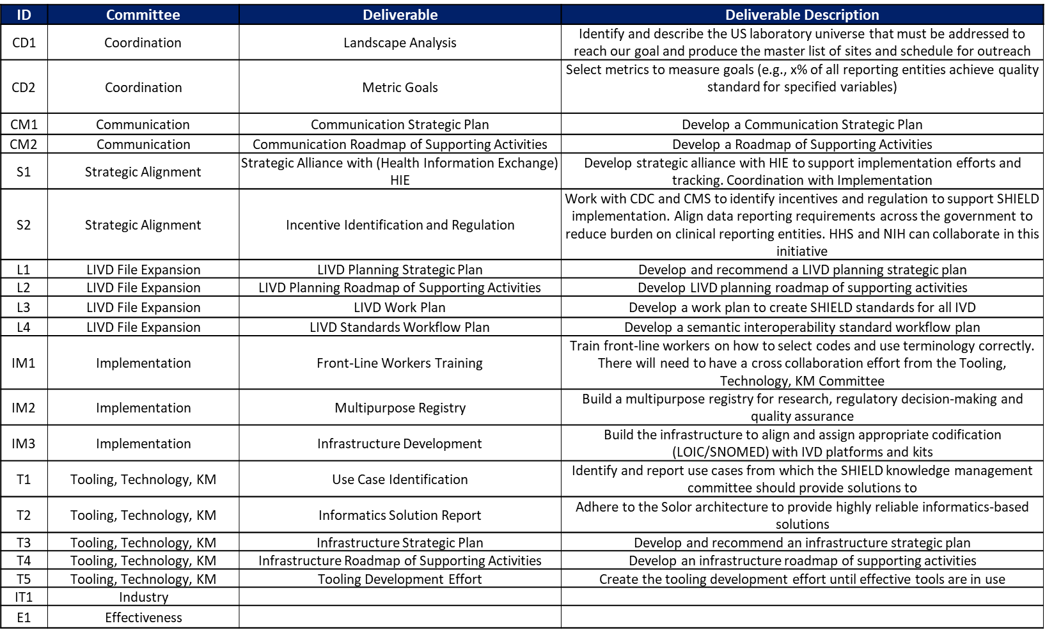

ACTIVITIES ROADMAP

[how about a method approach…
Year 1 – discovery and evaluation
Year 2 – Design
Year 3 validate/prototype
Year 4 and + implementation
]

FUNDING MODEL AND ALLOCATION
In order to deliver at the pace required and to singularly orient investments to business outcomes, a product-centric operating model has been suggested for SHIELD’s National Strategy for the Laboratory Interoperability and Pandemic Preparedness. This is a major cultural and operational change – and will result in better relationships with business and a less expensive, more efficient way to deliver higher-quality products.
[…. Continue]

MOVING FORWARD

APPENDIXES
- Laboratory Data Interoperability Strategy for the COVID-19 Response and Pandemic Preparedness White Paper
- SHIELD Strategic planning process document
- Committee reports (this could include committee materials, meeting minutes, reports and committee purpose/charter/background statements)

https://www.beckershospitalreview.com/ehrs/6-barriers-to-healthcare-interoperability-according-to-onc.html
https://documents.cap.org/documents/laboratory-interoperability-best-practices.pdf
https://symbiosisonlinepublishing.com/nursing-healthcare/nursing-health-care31.php

