SHIELD Project Status Report

Project Name: AST IVD REporting

Initiative Summary
Submission Date | Project Name | Submitted BY (SOurce) include email
28Mar23 | AST IVD Reporting: Immunoassay interpretation | Xavier Gansel (Biomerieux)

Summary of Problem/Issue/Need
Description of the Project/Issue(s)/Needs: IVD vendor mapping guidance of Antimicrobial Susceptibility Values in LIVD/LIDR, in LIS/EHRs/PH labs, and transmission to other LIS/EHR/PH, and use for RWD/RWE, surveillance, etc. (list all). Identification of coding, messaging gaps, and training/education needed. Issue: There are two different ways laboratories are modeling these results in their LIS/EHR and transferring/messaging to other information systems.

For Immunoassay interpretation results, with the following qualitative result values, recommended mapping is to SNOMED CT Qualifier Value codes. The Immunoassay results will be mapped to LOINC in the US. (May wish to include a list of immunoassays mapped to LOINC, and these values to SCT in LIVD if available)

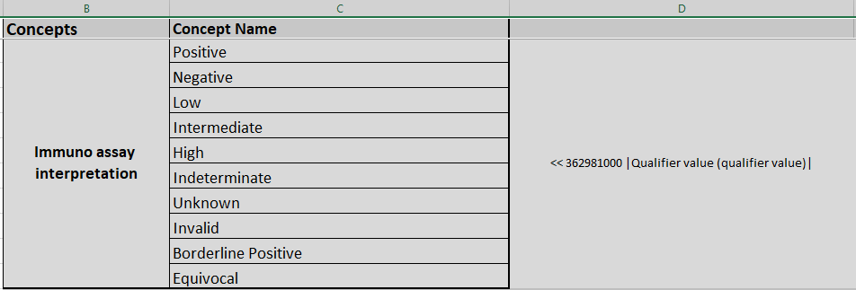

ITEM Overview
Item | Details | SC Comments
Types of Lab Data involved | Result values
Are data discrete? | Yes from IVD device and in LIS, EHR, PH system, etc
Existing standards? (Describe coding, messaging, etc.) | Use existing codes from SCT Qualifier hierarchy. IVD provides mapped result values in LIVD. LIS functionality to map to SCT qualifier values
---If no, gaps to be filled? | Confirm LIS, PH IS, and EHRs and other downstream systems all support mapping this item to SCT qualifier codes.  (May be out of scope for this, but APLIS systems may or may not have functionality to support for pathology result values, especially if immunoassay is mapped in LIS one way and used in APLIS structured/mapped differently. Any overlap?)
Exchangeable data? How? | HL7 V2 format: Value and mapped code in OBX5  FHIR Observation:  FHIR Diagnostic Report:  CDA:
---If no, gaps to be filled? | Confirm FHIR functionality is available
Where Occurs in Lab Workflow(s) (IVD, LIS, EHR, PH, RWE, etc.) | IVD, LIS, EHR, RWE
Who/What Impacted? (lab area, clinicians, PH, patients, labs, IVD vendors) | Microbiology for this use case, but also Chemistry, and Immunology, Serology for immunoassays and qualitative result values from hematology, blood bank, Pathology
Scope of Impact (Broad, Narrow, Global, Regional, etc.) | Broad. Global.
Who/What working upon? (e.g. SHIELD WG, external entity, none) | Looking for SHIELD Steering Committee Approval. For this item, a WG isn’t expected, but for related coding needs. Looking for required functionality in all information systems to send and receive. In USCDI, but looking for all information systems to have certification functionality to support. (additional CLIA needs/alignment/updates?, ONC/FDA/CDC regulatory/policy needs?)
Other Info to Consider (links, papers, etc.) | Links to papers, posters, analysis? List CLSI, EUCAST guidelines, etc.?

Proposed Solution(S)/Desired Outcomes
ITEM (List Each) | Solution Description | ASSIGNED TO | DATE
SC approval of mapping standard
IVD LIVD map creation
Policy/regulatory updates? | FDA IVD requirements? ONC LIS/EHR requirements? CDC/PH requirements
Marketing/education/implementation plan

Steering COmmittee Decisions
task | Vote? | DATE | Assigned TO | notes
Item Approved, Prioritized, or Parking Lot? |  |  | WG? External? | Indicate Review/Approval by SC and to whom assigned
More Info Needed?
Expected Timeline (start & end)
SC member(s) lead/liaison
Other SC members on task

Project Overview
task | Due date | Assigned TO | notes
SC approval |  | Co chairs
LIVD maps |  | IVD vendors
Policy/regulatory updates |  | agencies
Marketing/education? Implementation plan |  | SHIELD WG?
List other anticipated tasks

CONCLUSIONS/RECOMMENDATIONS

